SWH TOOLKIT DOCUMENT #3B

Your City logo here

Solar Pool Heating
Standard Plan
for One- and Two-Family Dwellings

SCOPE: Use this plan ONLY for solar pool heating systems not exceeding a thermal output rating of 30 kWth on the roof of a one- or two- family dwelling or accessory structure and used for residential solar pool heating. Systems must be in compliance with current California Building Standards Code, Title 24 and local amendments of the authority having jurisdiction (AHJ). Other articles of the California Plumbing Code (CPC) or California Mechanical Code (CMC) or other health and safety codes shall apply.

MANUFACTURER’S SPECIFICATION SHEETS MUST BE PROVIDED for proposed collector, controller, solar pump (if applicable), heat exchanger/heat transfer fluid (if applicable), diverting valve (if applicable) and mounting systems. Equipment intended for use with a solar pool heating system shall be identified and listed for the application.

Job Address: ___ _____ _____ Permit #: __ Contractor/Engineer Name: _ __ __ License # and Class: _ Signature: ______ Date: Phone Number: _ __
Email:
Total # of Collectors Installed Total Collector Area Collector Certification Number (include certifying agency) Collector Material
Max Height Above Roof Height Above Ground

Major components

Solar Control Make/Model

Solar Pump Make/Model (if applicable) Diverting Valve Make/Model
Mounting Hardware Make/Model or Type

SAMPLE ROOF PLAN for SDWH and SPH systems

-ROOF TYPE: STANDING SEAM

-ROOF HEIGHT (Elevation): MAX 15’ (1 story)

-RAFTERS: 2” X 6” @ 24” OC (18) 4’x12’ XXX PANELS
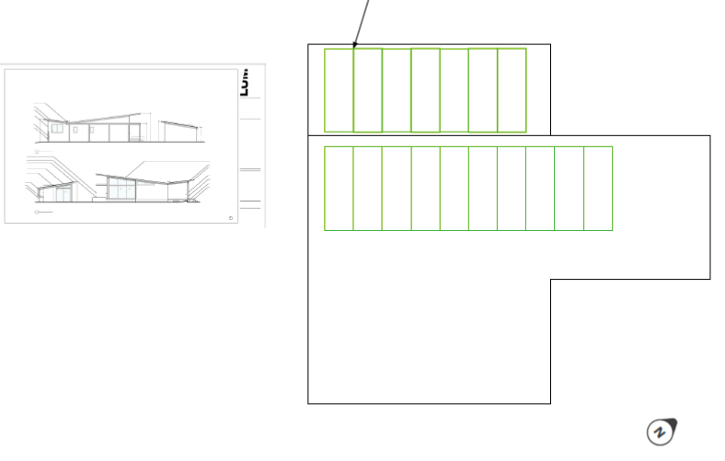

SAMPLE ONE LINE PLUMBING DIAGRAM
For SPH Systems

